Project SYNCHRO: Specification & Realization Plan (v6.0)
System for Yielding Networked CHannel Rail Operation
Allgemeine Gewerbeschule Basel (AGS) • Cross-departmental Projects 2026 (BÜP)
Status: Official Project Restart (Week 35 / Autumn Semester 2026)

1. Document Control & Project Metadata
Parameter | Specification / Project Data
Project Name | SYNCHRO (System for Yielding Networked CHannel Rail Operation)
Document Type | Specification, System Requirements & Realization Plan
Version | v1.0
Project Author | Jonas Henz
Project Duration | Week 35 / 2026 (August 24, 2026) to Week 51 / 2026 (December 2026)

2. Background & System Architecture
The SYNCHRO project aims to develop a modular, fault-tolerant ecosystem for the digital control of automated model railway systems. By decoupling sensitive logic components from high-current track drivers, SYNCHRO addresses common issues like ground loops and electrical interference.
The system is designed around a three-level architecture:
- Central Control Unit (SYNCHRO_Central): Handles logic, communication, and the generation of control signals.
- Power Driver Unit (SYNCHRO_Booster): Provides isolated power and signal amplification for the track network, with integrated protection mechanisms.
- Universal Peripheral Module (SYNCHRO_Module): Manages actuators such as turnouts, signals, and servos via isolated interfaces.

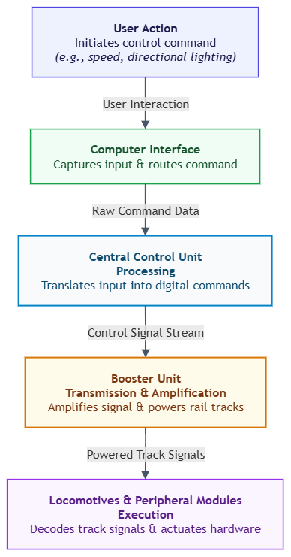

3. System Requirements
The specification follows institutional quality guidelines and distinguishes between mandatory criteria (shall) and optional criteria (should):

4.1 Mandatory Requirements (shall)
- M-01: The central control unit shall receive commands via standardized interfaces.
- M-02: The central control unit shall generate a control stream and transmit it to the power units.
- M-03: The power unit shall provide stable power supply and signal transmission to the track system.
- M-04: The peripheral modules shall decode signals and execute intended physical actions autonomously.

4.2 Optional Requirements (should)
- O-01: The power unit should feature an autonomous short-circuit protection mechanism with fast reaction times.
- O-02: Logic and power circuits should be galvanically isolated.
- O-03: The system should include protection components to mitigate electrical spikes.
- O-04: The system should support status indicators and manual reset functionality.
- O-05: The peripheral module should utilize a universal output design for various actuator types.

4. General Concept of Realization & Dimensioning

Assembly | Components | Dimensioning & Function
Galvanic Isolation | High-speed optocouplers, protection diodes | Input resistors for target diode current; antiparallel diodes protect against reverse voltage.
Power Stage | H-bridge driver, buffer capacitors | Clocks control signal; capacitors buffer load peaks; snubber dämpft high-frequency oscillation at output.
Short-Circuit Protection | Shunt resistor, comparator, latch logic | Voltage drop at threshold; low-pass filter removes interference peaks; latch prevents cycling.
Power Supply | Buck converter | Highly efficient provision of logic voltage from track voltage without thermal losses.

5. Project & Milestone Planning (Autumn Semester 2026)

Phase | Period | Milestones & Deliverables | Core Activities
Phase 1 | Week 35 – 37 | M1: Specification & Circuit Completion | Finalization of specification, verification of requirements, circuit simulation, component approval.
Phase 2 | Week 38 – 42 | M2: PCB Layout & Manufacturing Release | Board routing in KiCad (Thermal Vias, Star Ground), DRC checks, Gerber export, group ordering.
Phase 3 | Week 43 – 47 | M3: Prototyping & Partial Commissioning | SMD/THT assembly of booster boards, isolation testing, calibration of shutdown thresholds.
Phase 4 | Week 48 – 50 | M4: System Integration & SDS Report | Verbundtest Central → RJ45 → Booster → Module, load test on track, creation of interim report.
Phase 5 | Week 51 | M5: Project Completion & Presentation | Target/Actual comparison, archiving of all schematics/codes, final presentation at AGS.

